**ASCP2025 - 8th Concrete Pavements Conference, NSW, Australia**

**The Title of Your Paper Goes Here**

**Author**1**, Author**2

1 Position, Qualifications, Organisation  
2 Secondary Human, Qualifications, Organisation

Abstract

Lorem Ipsum is simply dummy text of the printing and typesetting industry. Lorem Ipsum has been the industry's standard dummy text ever since the 1500s, when an unknown printer took a galley of type and scrambled it to make a type specimen book. It has survived not only five centuries, but also the leap into electronic typesetting, remaining essentially unchanged. It was popularised in the 1960s with the release of Letraset sheets containing Lorem Ipsum passages, and more recently with desktop publishing software like Aldus PageMaker including versions of Lorem Ipsum. Lorem Ipsum is simply dummy text of the printing and typesetting industry. Lorem Ipsum has been the industry's standard dummy text ever since the 1500s, when an unknown printer took a galley of type and scrambled it to make a type specimen book. It has survived not only five centuries, but also the leap into electronic typesetting, remaining essentially unchanged. It was popularised in the 1960s with the release of Letraset sheets containing Lorem Ipsum passages, and more recently with desktop publishing software like Aldus PageMaker including versions of Lorem Ipsum.

Introduction

In 1985 Aldus Corporation launched its first desktop publishing program Aldus PageMaker for Apple Macintosh computers, released in 1987 for PCs running Windows 1.0. Both contained the variant lorem ipsum most common today. Laura Perry, then art director with Aldus, modified prior versions of **Lorem Ipsum** text from typographical specimens; in the 1960s and 1970s it appeared often in lettering catalogs by Letraset. Anecdotal evidence has it that Letraset used **Lorem ipsum** already from 1970 onwards, eg. for grids (page layouts) for ad agencies. Many early desktop publishing programs, eg. Adobe PageMaker, used it to create template.

Most text editors like MS Word or Lotus Notes generate random **lorem text** when needed, either as pre-installed module or plug-in to be added. Word selection or sequence don't necessarily match the original, which is intended to add variety. Presentation software like Keynote or Pages use it as a samples for screenplay layout. Content management software as Joomla, Drupal, Mambo, PHP-Nuke, WordPress, or Movable Type offer **Lorem Ipsum** plug-ins with the same functionality.

Heading1

Most text editors like MS Word or Lotus Notes generate random **lorem text** when needed, either as pre-installed module or plug-in to be added. Word selection or sequence don't necessarily match the original, which is intended to add variety. Presentation software like Keynote or Pages use it as a samples for screenplay layout. Content management software as Joomla,

Heading2

Drupal, Mambo, PHP-Nuke, WordPress, or Movable Type offer **Lorem Ipsum** plug-ins with the same functionality. Drupal, Mambo, PHP-Nuke, WordPress, or Movable Type offer **Lorem Ipsum** plug-ins with the same functionality.

Heading3

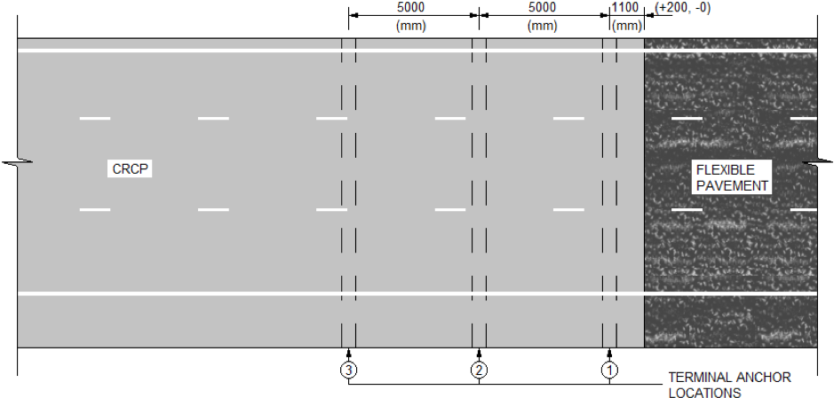Most text editors like MS Word or Lotus Notes generate random **lorem text** when needed, either as pre-installed module or plug-in to be added. Word selection or sequence don't necessarily match the original, which is intended to add variety. Presentation software like Keynote or Pages use it as a samples for screenplay layout.

Figure : This Figure number is automatic, select figure number then press F9 to update

Content management software as Joomla, Drupal, Mambo, PHP-Nuke, WordPress, or Movable Type offer **Lorem Ipsum** plug-ins with the same functionality.

### Heading3

Most text editors like MS Word or Lotus Notes generate random **lorem text** when needed, either as pre-installed module or plug-in to be added. Word selection or sequence don't necessarily match the original, which is intended to add variety. Presentation software like Keynote or Pages use it as a samples for screenplay layout. Content management software as Joomla, Drupal, Mambo, PHP-Nuke, WordPress, or Movable Type offer **Lorem Ipsum** plug-ins with the same functionality.

#### Heading4 – Bulleted List

* Area of steel for 3 x N24 exceeds the nominated area of steel (6 x N16)
* Scabble the formed face of the hardened concrete anchor prior to drilling
* Drill and tie 3 x 1000 mm long N24 bars, drilled equidistance apart (refer Figure 4)
* Drill and tie with epoxy to a minimum depth of 450 mm, (similar to an RMS C2d joint type)
* Undertake pull-out tests on the bars
* Remaining anchor sections must to be constructed as per RMS R83 and Standard Drawings (Volume. CC).

Heading3 – Numbered List

1. Area of steel for 3 x N24 exceeds the nominated area of steel (6 x N16)
2. Scabble the formed face of the hardened concrete anchor prior to drilling
3. Drill and tie 3 x 1000 mm long N24 bars, drilled equidistance apart (refer Figure 4)
4. Drill and tie with epoxy to a minimum depth of 450 mm, (similar to an RMS C2d joint type)
5. Undertake pull-out tests on the bars
6. Remaining anchor sections must to be constructed as per RMS R83 and Standard Drawings (Volume. CC).

## Heading

Lorem Ipsum is simply dummy text of the printing and typesetting industry. Lorem Ipsum has been the industry's standard dummy text ever since the 1500s, when an unknown printer took a galley of type and scrambled it to make a type specimen book. It has survived not only five centuries, but also the leap into electronic typesetting, remaining essentially unchanged. It was popularised in the 1960s with the release of Letraset sheets containing Lorem Ipsum passages, and more recently with desktop publishing software like Aldus PageMaker including versions of Lorem Ipsum.

Expectation

Lorem Ipsum is simply dummy text of the printing and typesetting industry. Lorem Ipsum has been the industry's standard dummy text ever since the 1500s, when an unknown printer took a galley of type and scrambled it to make a type specimen book. It has survived not only five centuries, but also the leap into electronic typesetting, remaining essentially unchanged.

Lorem Ipsum is simply dummy text of the printing and typesetting industry. Lorem Ipsum has been the industry's standard dummy text ever since the 1500s, when an unknown printer took a galley of type and scrambled it to make a type specimen book. It has survived not only five centuries, but also the leap into electronic typesetting, remaining essentially unchanged. It was popularised in the 1960s with the release of Letraset.

There was also the requirement for new utility crossings to be trenched under the existing pavement which added more slab replacements to the jointing design.

A JRCP jointing design was produced and a pavement profile to match the existing Parramatta Road pavement and was issued for construction.

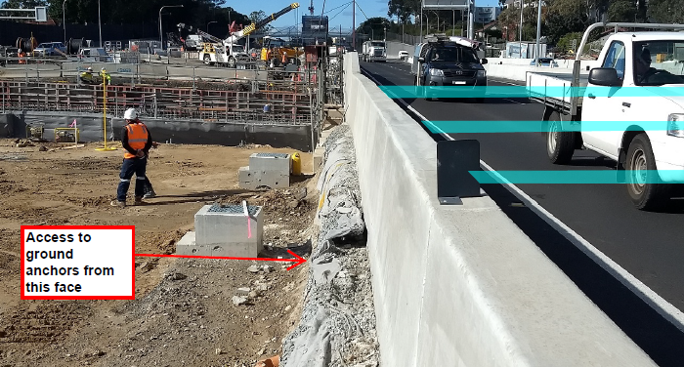

Figure : This Figure number is automatic, select figure number then press F9 to update

Reality

Prior to starting the pavement works on the eastbound carriageway the Lorem Ipsum is simply dummy text of the printing and typesetting industry. Lorem Ipsum has been the industry's standard dummy text ever since the 1500s, when an unknown printer took a galley of type and scrambled it to make a type specimen book. It has survived not only five centuries, but also the leap into electronic typesetting, remaining essentially unchanged. It was popularised in the 1960s with the release of Letraset sheets containing Lorem Ipsum passages, and more recently with desktop publishing software like Aldus PageMaker including versions of Lorem Ipsum.

Lorem Ipsum is simply dummy text of the printing and typesetting industry. Lorem Ipsum has been the industry's standard dummy text ever since the 1500s..

Adaption

Lorem Ipsum is simply dummy text of the printing and typesetting industry. Lorem Ipsum has been the industry's standard dummy text ever since the 1500s, when an unknown printer took a galley of type and scrambled it to make a type specimen book. It has survived not only five centuries, but also the leap into electronic typesetting, remaining essentially unchanged. It was popularised in the 1960s with the release of Letraset sheets containing Lorem Ipsum passages, and more recently with desktop publishing software like Aldus PageMaker including versions of Lorem Ipsum. Lorem Ipsum is simply dummy text of the printing and typesetting industry. Lorem Ipsum has been the industry's standard dummy text ever since the 1500s, when an unknown printer took a galley of type and scrambled it to make a type specimen book. It has survived not only five centuries, but also the leap into electronic typesetting, remaining essentially unchanged.

#### Details of the proposed design change

Lorem Ipsum is simply dummy text of the printing and typesetting industry. Lorem Ipsum has been the industry's standard dummy text ever since the 1500s, when an unknown printer took a galley of type and scrambled it to make a type specimen book. It has survived not only five centuries, but also the leap into electronic typesetting, remaining essentially unchanged. It was popularised in the 1960s with the release of Letraset sheets containing Lorem Ipsum passages, and more recently with desktop publishing software like Aldus PageMaker including versions of Lorem Ipsum.

#### Benefits of the design change

Lorem Ipsum is simply dummy text of the printing and typesetting industry. Lorem Ipsum has been the industry's standard dummy text ever since the 1500s, when an unknown printer took a galley of type and scrambled it to make a type specimen book. It has survived not only five centuries, but also the leap into electronic typesetting, remaining essentially unchanged.

It was popularised in the 1960s with the release of Letraset sheets containing Lorem Ipsum passages, and more recently with desktop publishing software like Aldus PageMaker including versions of Lorem Ipsum.

#### Potential risks

Lorem Ipsum is simply dummy text of the printing and typesetting industry. Lorem Ipsum has been the industry's standard dummy text ever since the 1500s, when an unknown printer took a galley of type and scrambled it to make a type specimen book. It has survived not only five centuries, but also the leap into electronic typesetting, remaining essentially unchanged.

It was popularised in the 1960s with the release of Letraset sheets containing Lorem Ipsum passages, and more recently with desktop publishing software like Aldus PageMaker including versions of Lorem Ipsum..

Expansive forces are present in the CRCP where it is restrained to isolate it from structures such as bridges, and subject to large temperature changes. These forces are normally managed by installing anchors and providing additional reinforcing steel to counter the additional compressive stresses.

Please note that the preparation of the rock formation support prior to construction of the protection slabs would result in a smooth interface between the rock and the protection slabs which is unlikely to generate significant friction forces associated with minor movements of the slabs.

#### Disposition of risk

Lorem Ipsum is simply dummy text of the printing and typesetting industry. Lorem Ipsum has been the industry's standard dummy text ever since the 1500s, when an unknown printer took a galley of type and scrambled it to make a type specimen book. It has survived not only five centuries, but also the leap into electronic typesetting, remaining essentially unchanged.

It was popularised in the 1960s with the release of Letraset sheets containing Lorem Ipsum passages, and more recently with desktop publishing software like Aldus PageMaker including versions of Lorem Ipsum..

This would comprise L1-N16-4000 at 3 x 'C' bar centres tied beside or under the C-N20 bars.

#### Calculations

The assumptions for the calculations are:

1. Sewer slab crosses the ramp transversely in an east/west direction
2. CoTE (coefficient of thermal expansion) of concrete = 10E+-06 per ºC (from AS 3600)
3. Temperature range in tunnel proper is 20 to 25 deg C. Therefore ΔT = 5 ºC
4. Temperature range in cut and cover tunnel is 15 to 30 ºC.   
   Therefore ΔT = 15 ºC
5. CRCP has existing transverse cracks which are 0.15 mm (on average) width at a spacing of 1.5 m
6. Tunnel proper CRCP is approx. 8000 m long from the northern side of the sewer slab
7. Cut and cover CRCP is approx. 200 m long from the southern side of the sewer slab
8. Modulus (E) of concrete is 30,000 MPa

Conclusion

Lorem Ipsum is simply dummy text of the printing and typesetting industry. Lorem Ipsum has been the industry's standard dummy text ever since the 1500s, when an unknown printer took a galley of type and scrambled it to make a type specimen book. It has survived not only five centuries, but also the leap into electronic typesetting, remaining essentially unchanged. It was popularised in the 1960s with the release of Letraset sheets containing Lorem Ipsum passages, and more recently with desktop publishing software like Aldus PageMaker including versions of Lorem Ipsum.

Acknowledgements

I would like to acknowledge the following people for their help in producing this paper:

**NAME** – *Company*

**NAME** – *Company*

**WestConnex Stage 1B CSJ team**

Table X – This is a sample table

|  |  |
| --- | --- |
| THIS IS A MERGED HEADER CELL | |
| **ABCD** | N16 longitudinal reinforcement bars in CRC |
| **ABCD** | N16 longitudinal reinforcement bars in CRC |
| **ABCD** | N16 longitudinal reinforcement bars in CRC |
| **ABCD** | N16 longitudinal reinforcement bars in CRC |
| **ABCD** | N16 longitudinal reinforcement bars in CRC |
| **ABCD** | N16 longitudinal reinforcement bars in CRC |
| **ABCD** | N16 longitudinal reinforcement bars in CRC |
| **ABCD** | N16 longitudinal reinforcement bars in CRC |
| **ABCD** | N16 longitudinal reinforcement bars in CRC |
| THIS IS A MERGED HEADER CELL | |
| **HEADER CELL FOR LONG CONTENT** | **Lorem ipsum** is a pseudo-Latin text used in web design, typography, layout, and printing in place of English to emphasise design elements over content. It's also called placeholder (or filler) text. It's a convenient tool for mock-ups. It helps to outline the visual elements of a document or presentation, eg. typography, font, or layout. |

Table 1: This table number is automatic, select table number then press F9 to update